**Crowdfunding Challenge**

* **Given the provided data, what are three conclusions that we can draw about crowdfunding campaigns?**

**Ans 1:** More than half of the campaigns were successful. This implies a fund raiser had a 50% chance of getting his project funded, all things being equal.

**2:** The United States counted for approximately ¾ of all campaigns during this period (See ‘addendum” tab on the attached excel file for more insights)

**3:** Fields/Columns with numerical data type exhibited huge variability and the data ranges are not normally distributed.

* **What are some limitations of this dataset?**

**Ans:** One of the limitations of the dataset is the absence of a summary description (or a sought of metadata) describing the fields or column headers. This could have given the reader/analyst an insight into the data they would be analyzing.

The dataset needs some clean up and columns formatting. For example, the “launched_at” and “deadline” used to be formatted into a meaningful data form that is intelligible to the readers. Also, some of the columns need splitting into more than one column to allow for further analysis, where possible.

* **What are some other possible tables and/or graphs that we could create, and what additional value would they provide?**

**Ans:** A boxplot can provide more details or analytical insights to the dataset such as quartile ranges as well reveling underlying outliers in a data range. The chart below is a boxplot for backers of successful outcomes, and from it we can calculate interesting statistics from it.

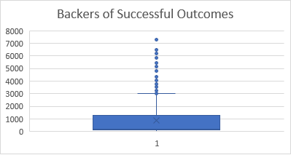

Another interesting chart would be a scatter/trend line analysis, which shows relationships between two or more fields/columns. As an example, we can fit in a trend line in a scatter chat to identify if there is a positive, negative or no relationship between the goal amount and the number of pledges from the data set.